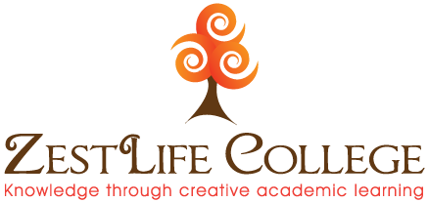
Diploma in Integrative Counselling & Psychotherapy
Application Form
Name: ____________________________________________________________________
Address: _________________________________________________________________
____________________________________________________________________________
Start date of the course you wish to apply for: _______________________
Please attach a photo of yourself taken in the last year to the top left area of this application:
Date of Birth: ____________________________________________________________
Tel: ___________________ Mobile: _________________________________________
E-mail: ___________________________________________________________________

How did you hear about this course? ____________________________________________________________________________
____________________________________________________________________________
Where did you do your Foundation Course in Counselling? Please specify how many hours covered and attach Certificate. ____________________________________________________________________________________________________________________________________________________________________________________________________________________________________
Nationality: __________________
Is English your first speaking language?______________________________
Do you have any specific learning requirements? ___________________
Do you have any specific physical ability requirements?____________
(ZestLife has wheelchair access)

Educational Qualifications: ________________________________________________________________________________________________________________________________________________________________________________________________________________________________________________________________________________________________________________

References:
Please provide 2 references stating name, address, contact phone number and reason for this person as a referee: (Not family friends)____________________________________________________________________________________________________________________________________________________________________________________________________________________________________________________________________________________________________________________________________________________________________________________________
Give a brief explanation of why you would like to undertake this Diploma course: ____________________________________________________________________________________________________________________________________________________________________________________________________________________________________________________________________________________________________________________________________________________________________________________________________________________________________________________________________________________________________________________________________________________
I understand ZestLife College’s approach to learning is to supply a Diploma in Integrative Counselling & Psychotherapy that applies 3 principles of teaching . An excellent academic course, developing theory into practice and creating personal awareness of my own development and action required to become an effective therapist and I confident of my willingness to embrace this teaching philosophy. Yes/No
I enclose a deposit of €500 Yes/ No
I have transferred deposit of €500 online Yes/ No

I would like to apply for the ZestLife College Diploma in Integrative Counselling & Psychotherapy

Signed: ________________________________

Please send this form to:
Stuart Wilson
ZestLife College
Crossroads Centre
Unit 1a Earlscourt Industrial Estate
Beaumont Ave., Churchtown, Dublin 14

Tel: 01 296 6047
www.zestlife.ie

